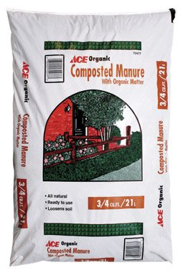
Ace Composted Manure

- .75 Cubic Foot Coverage
- Ready to use
#16
- Organic

$2.99
7202013

